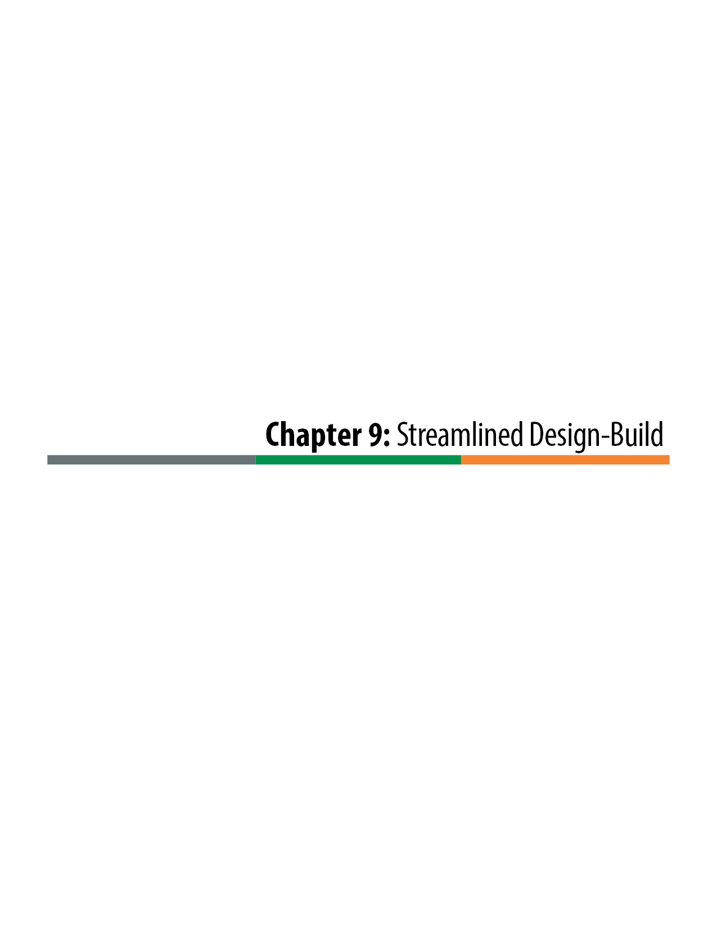

Streamlined Design-Build
Streamlined Design-Build (SDB) provides a simplified and efficient approach to Design-Build Delivery that can be applied to small and less complex projects. It is characterized by a single step procurement process that significantly reduces the procurement process, both with regard to the schedule and the effort required by the CDOT project team and the proposers.

Procurement
The procurement process is defined through the Instructions to Proposers (ITP), which is significantly different for SDB than a full two-step Design-Build project. An ITP template for SDB is provided in the online Appendix on the CDOT Innovative Contracting web page or by contacting CDOT Innovative Contracting. Key elements of the SDB ITP are:
Project Briefing: Though this is an optional step in the process, it is generally recommended to ensure that proposers understand the unique characteristics of SDB procurement. Contractor attendance at the project briefing can be either mandatory or optional. An advantage of making the briefing mandatory is that it allows CDOT to better understand the number of and nature of the possible proposers.
Alternative Technical Concepts (ATCs): SDB allows for submittal of ATCs, similar to full Design-Build delivery. The ATC process is a critical element of best value in SDB, allowing proposers to modify the project requirements to provide equal or better value to CDOT in the most cost-efficient manner. To facilitate the ATC process, a period of time is set aside for proposer one-on-one meetings. The one-on-one meetings are not mandatory and are scheduled on a first-come, first-served basis. CDOT must provide the opportunity for at least a single one-on-one meeting for each proposer that requests a meeting within the allowed time period. In rare instances, it may be necessary to extend the meeting period by addendum to provide the necessary meetings.
Pass/Fail Evaluation of Proposals: Brief technical proposals are required from the proposers. The purpose of the technical proposals is to ensure that the proposers are technically qualified to perform the work. The technical proposals are not intended to be used to short-list the most qualified proposers and eliminate other qualified proposers from consideration.
Price Proposal (Bid): The selection is on the basis of a price proposal. Though the price proposal can include an adjustment for time (A+B), it should be in the form of a mathematical formula that can be calculated at the bid opening without subjective elements; this keeps the entire evaluation process straightforward, efficient, and less likely to be subject to protest.
Stipends: As with traditional Design-Build projects, it can be beneficial with SDB projects to offer a stipend to unsuccessful responsive submitters. Because the process is single step without a short-listing phase, the number of contractors that will submit Proposals is unknown. To limit the potential of an excessive total stipend payout to a large number of proposers, the total stipend amount is usually set in the ITP, with the statement that it will be distributed equally to the top three unsuccessful responsive submitters.

RFP and Contract Documents
The Request for Proposal (RFP) and Contract Documents for SDB are the same as those for full Design-Build with one notable exception. Instead of using the standard Design-Build Book 1 for the Contract, SDB uses Division 100 of the CDOT Standard Specifications. This approach allows project teams to rely on Contract provisions that they are usually very familiar with from their experience on traditional Design-Bid-Build (D-B-B) projects. For the standard Division 100 to be applicable to SDB, it is necessary to modify a number of its provisions. The modifications are provided through Section 1 (General) of the Technical Requirements, which includes Project Special Provisions for Division 100. Most of the revisions are related to Contract management of design work that is not a part of the Standard Specifications. Examples are: professional liability insurance provisions; key Design-Build terminology, such as the definitions of Approval and Acceptance; and a two-step NTP process to allow early initiation of the design process. A template for the Streamlined Division 100 Project Special Provision is available in the online Appendix on the CDOT Innovative Contracting web page or by contacting CDOT Innovative Contracting.
The other sections of the Book 2, Technical Requirements are for the most part the same for SDB as for full Design-Build, and SDB delivery can make use of templates that have already been developed. One notable difference is in the Technical Requirement Section 3, Quality Management. In full Design-Build the Contractor often provides Acceptance testing and inspection through ICQC. In SDB, however, it is usually the best approach for CDOT to provide Acceptance testing and inspection for the project in a manner similar to traditional D-B-B.
